Difference between Docker and Virtual machine

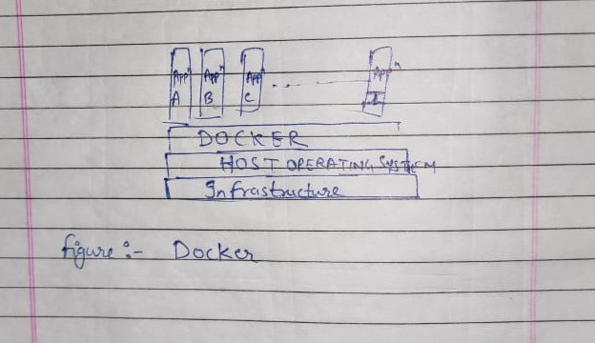

Docker uses single operating system kernel , so it uses fewer resources and so it gets boots fastly than virtual machine. Docker is a lightweight, open source containerization technology.

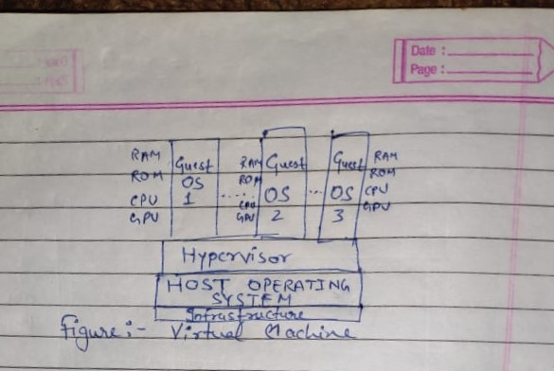

Hypervisor:- It allows to create a virtual environment in which guest virtual machine can operate.

Virtualisation:- It’s a method which allows to run multiple operating system simultaneously. The main benefit of virtualisation is that resources can be easily distributed.

Virtual machine uses shared operating system kernel , that’s the resources get shared thus it gets boots little slower than Docker. The virtual machine isn’t lightweight as docker , it’s in GBs.